**Assignment 2 Web Application**

**Name:** Dussart Noémie

**E-Mail:** noemie.dussart2@mail.dcu.ie

**ID Number:** 22104542

**Programme:** ECEF1 Study Abroad ECSAOO

**Date:** 24/10/2022

To have access to the Website, the user needs to find the file **INDEX_jvs.html**. This file contains the entrance of the website.



**Dynamic Menu Bar:**

The INDEX page is built on a dynamic way. Indeed, depending on the size of the page, the menu bar adapts itself. We the page is on a full screen; the user can see the entire menu without clicking on any button:



When the screen is little in size, the menu bar is hidden, and the user need to click on a symbol to make the bar appears:

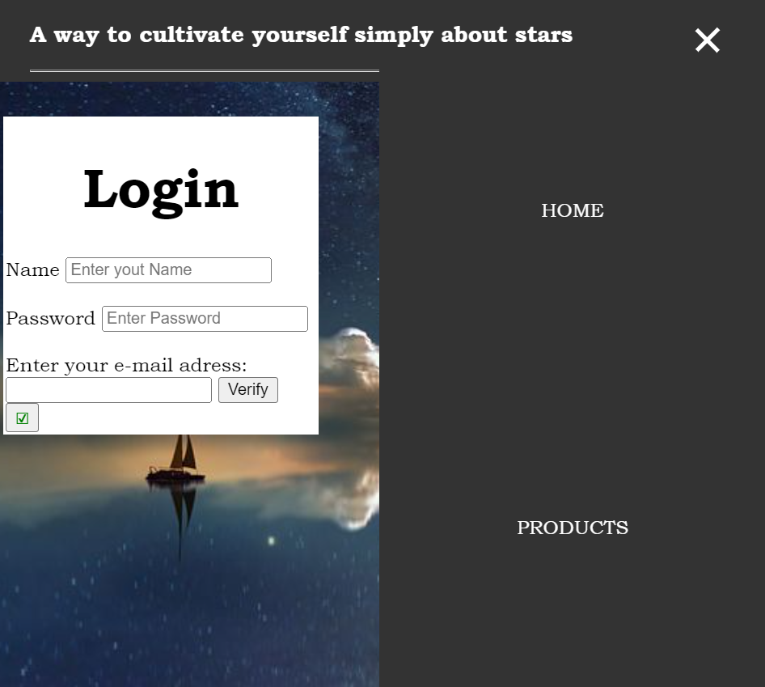

Moreover, when the user makes his mouse on the subjects, here *HOME* and *PRODUCTS*, the title change colour and there is a dynamic movement in it.

On the first page, we have a login part. In it, we make write the *Name* and the *Password* of your choice. To make it confidential, the *password* can be hidden. Then, we can enter an e-mail address and verify if the form is the right one. If it isn’t an **alert** will be shown to warn the user that the email is incorrect:

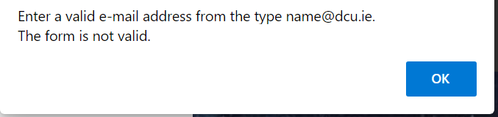

To enter on the website, there are two possible choices. The first one is to click directly on the *HOMES* words on the bar menu. Or to click on the symbol 🗹 on the *Login* page.

On the principal page, we have another dynamic menu bar on the left side:

When the user clicks on it, a dynamic bar is shown:

On top of the colour band, there is a cross, when clicks on it, the menu bar disappears.

This type of menu is on all the html pages created for the website, to make it simpler for the user to navigate through the various pages.

On the code parts, all the lines that were used for the creation of the dynamic menu are commented.

**Form Data Validation/Storage:**

For this part, 3 different forms data were created.

The first one, **Registration Form** contains various input for the user to enter element of his choice. This file is located on the menu in the section **Forms**, which can be find in the blue menu or in the black menu.

The form is presented this way:

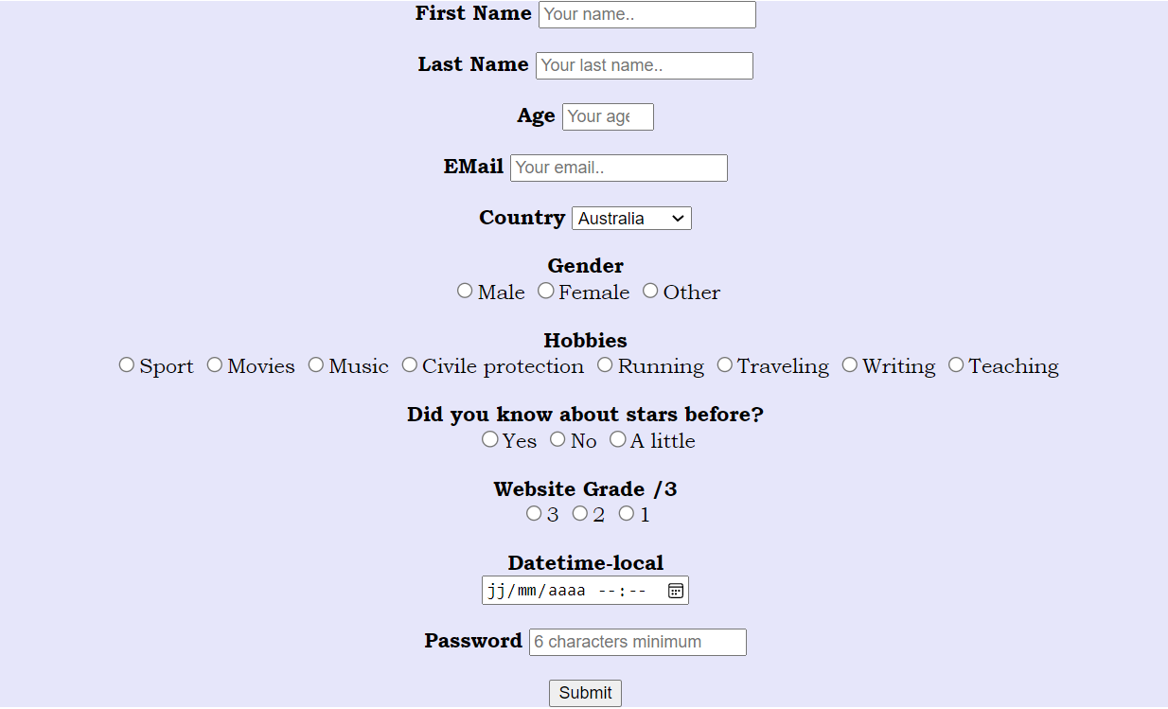

The user can enter his *name*, his *last name*, his *age*, his *email*, and his *country*. Then he must put his *gender*, the *hobby* and if known something already about stars. The, he must put a *grade* on 3 about the website. He can also put the *date* when the form where written and finally put the *password* of his choice, which will be hidden.

When the button *Submit* is clicks on, the elements will be kept in memory and will be display on the website page.

For example, this one was already created:

When all the elements are filed on the forms, the information are display on the left size the following way:

Every time the *submit* button is clicks on it, all the element area are clear for the user to enter other information.

The second Forms register is built differently. The name of the second form is **Register**, which is contains on the section **Forms** on the menu bar in blue.

The form is presented this way:

In this form, we can enter the *username*, the *email,* and a *password*. Then, we can **Register** those information, which then will be contain in a **.txt. file:**

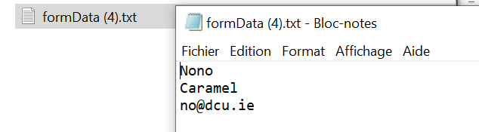

The third form register is built in another way again. It can be found in the blue menu bar at the name **Forum post**. It is presented this way:

On this register, we can enter *Name*, *Topic, a writing post,* and an *additional tag*. At the end of the registration, we can enter any file we want. Here, we will chose the one we created previously on the second form. (**FormData(4)**)

When we enter this file on the website, we have the following display:



Which is the information we enter previously.

On the code parts, all the lines that were used for the creation of the forms are commented.

**Event Capturing /DOM tree:**

To build the website with dynamic JavaScript by taken the enter elements, we needed to use *DOM* code elements. Those elements are in the **<script>** part and are commented when used.

In the part of the file *Constellations*, I included a part of JavaScript to create a loop. I used event and DOM lines for it.